**Group Ideas**

**Lab section: TH. 2:30pm**

**Lab member: Ni Kang, Haobo Chen, Haoming Zhang**

**Edge detection:**

Edge detection is a basic problem for image processing and computer visualization, whose aim is to denote the points which change obviously in digital image. The obvious changes in image properties usually reflect the property’s important events and changes, which includes: discontinuity in depth, discontinuity on surface, the changes in matter properties and the brightness change in a specific scenario. Image edge detection drastically decreases the number of data and eliminates the irrelevant information which keeps the important properties of the image structure. There are a lot of ways to be used in edge detection, and they can be divided into two parts. The first part is to find the maximum and minimum value in the first derivation of the image. The second part is to find the edge through find the second derivation of the image.

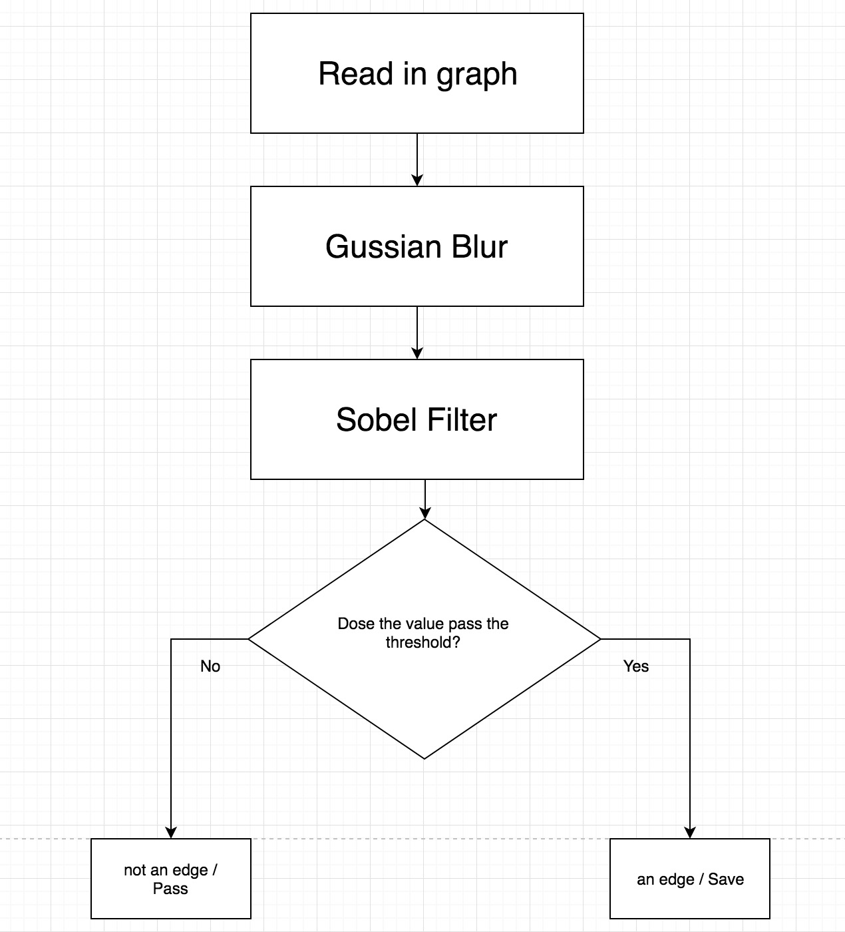

**AES**

The [National Institute of Standards and Technology (NIST)](http://searchsoftwarequality.techtarget.com/definition/NIST) started development of AES in 1997 when it announced the need for a successor algorithm for the [Data Encryption Standard (DES)](http://searchsecurity.techtarget.com/definition/Data-Encryption-Standard), which was starting to become vulnerable to [brute-force attacks](http://searchsecurity.techtarget.com/definition/brute-force-cracking). This new, advanced encryption [algorithm](http://whatis.techtarget.com/definition/algorithm) would be unclassified and had to be "capable of protecting sensitive government information well into the next century," according to the NIST announcement of the process for development of an advanced [encryption](http://searchsecurity.techtarget.com/definition/encryption) standard algorithm. It was intended to be easy to implement in hardware and software, as well as in restricted environments (for example, in a [smart card](http://searchsecurity.techtarget.com/definition/smart-card)) and offer good defenses against various attack techniques.

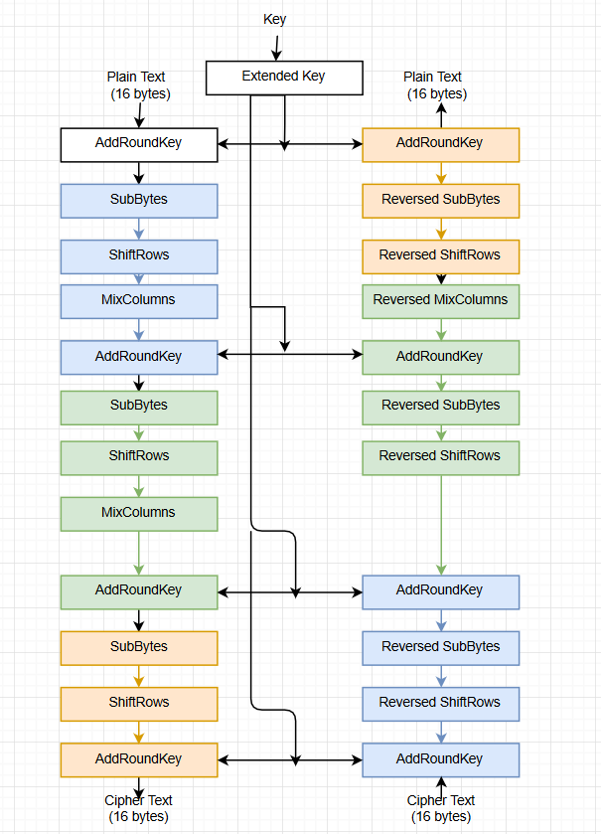

**Huffman Coding**

Huffman coding is a lossless data compression algorithm. The idea is to assign variable-length codes to input characters, lengths of the assigned codes are based on the frequencies of corresponding characters. The most frequent character gets the smallest code and the least frequent character gets the largest code. The variable-length codes assigned to input characters are [Prefix Codes](http://en.wikipedia.org/wiki/Prefix_code), means the codes (bit sequences) are assigned in such a way that the code assigned to one character is not prefix of code assigned to any other character. This is how Huffman Coding makes sure that there is no ambiguity when decoding the generated bit stream.There are mainly two major parts in Huffman Coding: **1)** Build a Huffman Tree from input characters. **2)** Traverse the Huffman Tree and assign codes to characters.

